Product Requirements Document: Multi-Tenancy & Metering Foundation for RACKAI Platform
Amine Badaoui
Table of Contents
1. Vision 5
2. Problem Statement 5
3. Product Principles 6
3.1. Shared Infrastructure, Private Experience 6
3.2. Quotas are Guardrails, Not Barriers 6
3.3. Everything is Attributed 7
3.4. Fairness by Design 7
3.5. Transparency Builds Trust 7
3.6. Consistent Across the Lifecycle 7
3.7. Tenant Control 7
4. Scope 7
In Scope 7
Out of Scope 7
5. Key Outcomes 8
For Tenants 8
For Rackspace 8
For Platform Operations 8
6. Core Entities 9
Tenant 10
Project 10
Workload 10
Model 10
Usage Record 10
7. System Boundaries 10
Platform Dependencies & Integration Model 11
Core Dependency Systems 11
Integration Principle 12
8. Request Lifecycle (High-Level Flow) 12
9. Core Capabilities 13
9.1 Tenant Isolation 13
9.2 Workload Execution Model 14
9.3 Unified Metering Across the Lifecycle 15
9.4 Metered Usage Dimensions 15
9.5 Compute & Execution Signals 17
9.6 Key Requirements 17
9.7 Metering Event Structure (Conceptual) 18
9.8 Consistency Model 19
9.9 Idempotency & Reliability 19
10. Cost Attribution & Transparency 20
Cost Attribution 20
Primary Cost Drivers 20
Shared Inference Cost Attribution 20
Shared Execution Model 20
Attribution Principle 20
Cost Allocation Model 21
Caching Considerations 21
Transparency Requirements 21
Outcome 21
Visibility 22
Transparency Requirements 22
User-Level Clarity 22
Example: Usage & Cost Breakdown 22
Tenant: Acme Corp 22
Inference Usage (Shared Model) 22
Fine-Tuning Usage (Tenant-Specific Execution) 23
Execution Breakdown 23
Total Estimated Cost 23
Key Insights 23
User-Level Explanation 23
API-Accessible Metering & Billing 24
11. Fair Usage & Quota Enforcement 24
Enforcement Mechanisms 24
Enforcement Timing 25
Scope of Enforcement 25
Enforcement Principles 25
Budget Protection 26
Enforcement Behavior 26
Outcome 27
12. Usage Visibility 27
Real-Time Visibility 27
Historical Insights 27
Breakdowns & Dimensions 28
User Capabilities 28
Outcome 29
Example: Behavior When Limits Are Reached 29
Scenario: Tenant Approaches Token Limit 30
System Behavior Principles 30
Outcome 31
13. Quota Types 31
1. Token-Based Quotas (Inference) 31
2. Request-Based Quotas 31
3. Concurrency Quotas 32
4. Compute-Based Quotas (Training / Fine-Tuning) 32
5. Budget-Based Quotas 32
Quota Behavior Requirements 32
How Quotas Work Together 32
Outcome 33
14. Key Risks 33
1. Inaccurate Metering 33
2. Cache Misuse or Misattribution 34
3. Noisy Neighbor Effects 34
4. Quota Misconfiguration 34
5. Lack of Cost Transparency 34
6. Mitigation Approach 34
15. Failure Handling 35
16. Success Criteria 35
17. Summary 35
Platform Impact 36
Operational Outcome 36
Final Statement 36

Document Name | Multi-Tenancy & Metering Foundation PRD
Version | v1.0
Status | Review
Author | Amine Badaoui
Date Created | 27/04/2026
Last Updated | 27/04/2026
Stakeholders | Product, Engineering
Reviewers

1. Vision
Build a platform where RackAI tenants can deploy, fine-tune, and use AI models on shared infrastructure, while ensuring:
- Strict isolation
Each tenant’s workload, data, and usage are fully separated, allowing them to operate with the confidence of dedicated infrastructure.
- Fair resource usage
RackAI ensures that no tenant can negatively impact others, maintaining consistent performance and reliability across all users.
- Transparent and accurate cost attribution
Every action, workload is clearly measured and attributed, providing full visibility into usage and cost.
RackAI should make shared AI infrastructure feel:
- Private
Tenants have full control over their workload and data, with no visibility or interference from others.
- Predictable
Performance, limits, and costs behave consistently, enabling teams to plan and operate with confidence.
- Accountable
Every unit of usage is traceable, explainable, and tied to a tenant, project, or workload.

2. Problem Statement
As RACKAI adoption grows, the platform faces a fundamental tension:
- Efficiency requires shared infrastructure
- Customers require isolation, fairness, and cost clarity
Without a strong multi-tenancy and metering foundation:
- tenants may interfere with each other, impacting performance and reliability
- usage cannot be accurately attributed
- pricing becomes difficult to trust or validate
- infrastructure is duplicated, reducing efficiency
This creates risk for both customers and the business, through margin pressure and challenges to scaling efficiently.
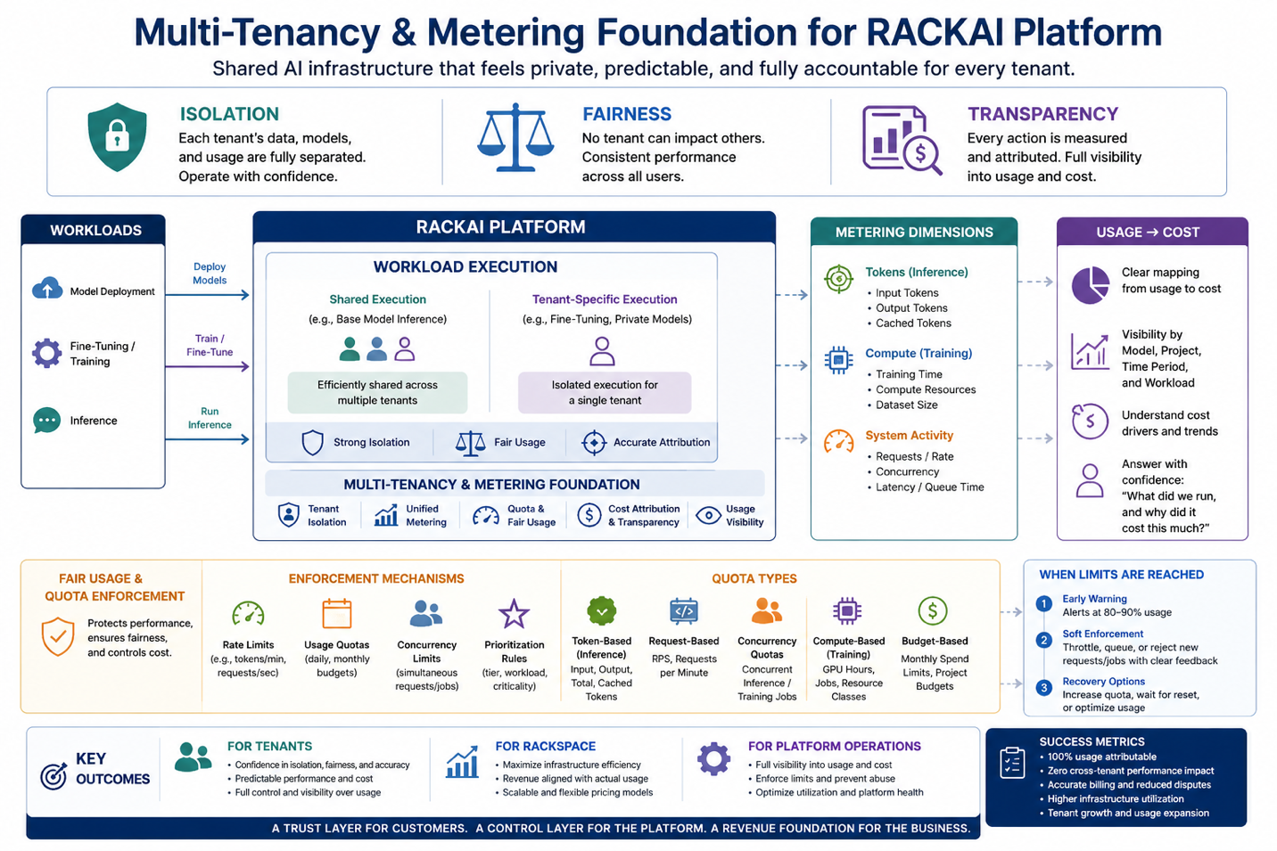

3. Product Principles

3.1. Shared Infrastructure, Private Experience
Tenants run on shared infrastructure but experience full isolation of their data, models, jobs and usage.

3.2. Quotas are Guardrails, Not Barriers
Limits provide control and predictability without blocking growth.
Tenants can see, manage, and expand their usage as needed.

3.3. Everything is Attributed
Every action, workload is tracked and attributable to a tenant and project.

3.4. Fairness by Design
No tenant can degrade another tenant’s performance or experience.

3.5. Transparency Builds Trust
Usage and cost must always be visible, understandable, and explainable.

3.6. Consistent Across the Lifecycle
Isolation, metering, and controls apply uniformly across workloads.

3.7. Tenant Control
Tenants must be able to actively control their usage through:
- quotas
- budgets
- access policies

4. Scope
This PRD defines how the platform handles:

In Scope
- Tenant isolation
- Workload execution models (shared vs tenant-specific)
- Usage tracking (inference and fine-tuning)
- Cost attribution
- Quotas and fairness controls

Out of Scope
- Model architectures
- UI/UX specifics beyond usage visibility

5. Key Outcomes

For Tenants
- Confidence that:
  - their data and workloads are isolated
  - their usage is accurately tracked
  - their costs are predictable and explainable
- Ability to:
  - use shared infrastructure safely
  - understand and control their consumption

For Rackspace
- Maximize infrastructure efficiency through shared usage
- Ensure revenue aligns with actual consumption
- Enable scalable and flexible pricing models

For Platform Operations
- Full visibility into:
  - who is using what
  - where resources are consumed
- Ability to:
  - enforce limits
  - prevent abuse
  - optimize utilization

6. Core Entities

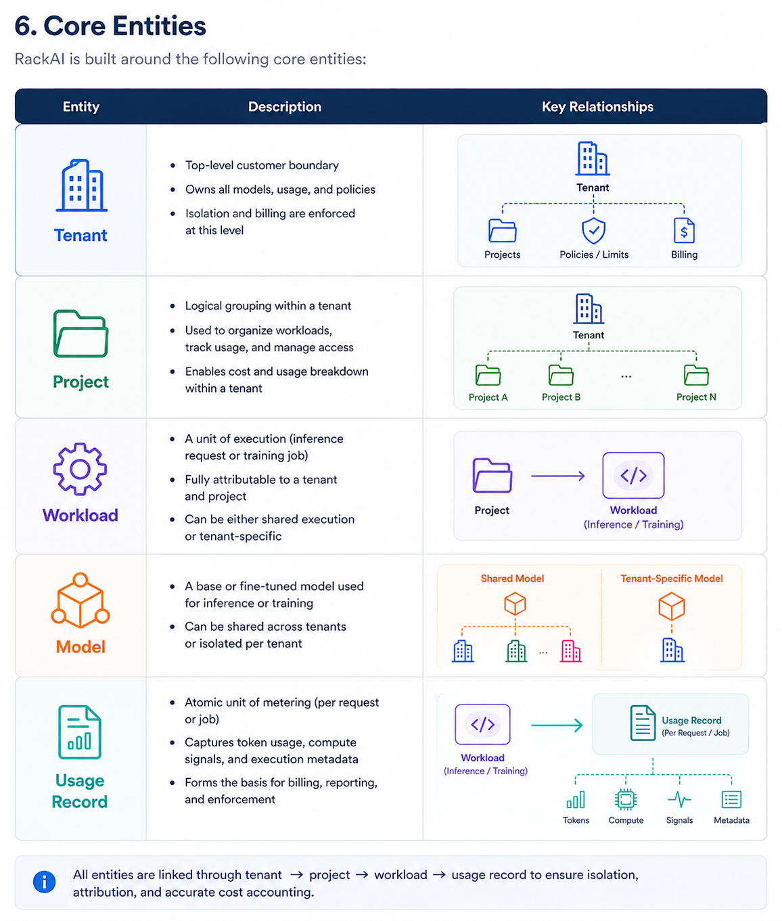

Tenant
- Top-level customer boundary
- Owns all workloads, usage, and policies
- Isolation and billing are enforced at this level

Project
- Logical grouping within a tenant
- Used to organize workloads, track usage, and manage access
- Enables cost and usage breakdown within a tenant

Workload
- A unit of execution (inference request or fine tuning job)
- Fully attributable to a tenant and project
- Can be either shared execution or tenant-specific

Model
- A base or fine-tuned model used for inference or training

Usage Record
- Atomic unit of metering (per request or job)
- Captures token usage, compute signals, and execution metadata
- Forms the basis for billing, reporting, and enforcement

7. System Boundaries
The platform consists of the following logical components:
- Inference Services
  - Execute model requests (shared or tenant-specific)
- Fine tuning Services
  - Execute fine tuning jobs
- Data Ingestion & Management Services
o Allow tenants to upload and manage datasets for fine-tuning
o Validate and store data for training workflows
o Ensure data isolation and secure access per tenant
- Metering System
  - Captures usage records for all workloads
- Quota & Enforcement System
  - Applies limits and controls usage in real time
- Billing & Reporting Systems
  - Consume usage data for cost calculation and visibility
External Dependencies
- data storage systems
- authentication and identity systems
- Monitoring systems

Platform Dependencies & Integration Model
The multi-tenancy and metering system operates as a core platform layer and depends on several external systems for authentication, authorization, control, and observability.

Core Dependency Systems
The following systems are not implemented within this PRD but are required for correct operation:

Authentication Provider
- validates user and service identity
- provides tokens (user / API key)
- establishes tenant context

RBAC System
- determines whether a request is authorized
- defines access to:
  - models
  - datasets
  - usage and billing data
- enforced before any workload execution

Quota Management System
- enforces limits on:
  - token usage
  - compute usage
  - request rates
- operates in real time alongside metering

Secrets Management
- provides secure access to credentials
- ensures tenant-scoped isolation

Observability & Monitoring
- captures metrics, logs, and traces
- supports debugging, auditing, and cost visibility

Integration Principle
The system must ensure:
- no workload executes without RBAC authorization
- no workload executes without quota validation
- all workloads generate metering events
- all usage is attributable to tenant and project context

System Responsibility Boundaries
The multi-tenancy and metering system is responsible for:
- tracking usage across all workloads
- attributing usage to tenants and projects
- generating usage records for billing
- ensuring accurate and auditable cost attribution
The system is not responsible for:
- user authentication (handled by Auth Provider)
- access authorization (handled by RBAC system)
- quota policy definition (handled by Quota system)
- secrets storage (handled by Secrets Management)

Concern | Owned By
Identity | Auth Provider
Authorization | RBAC
Usage Limits | Quota System
Usage Tracking | Metering System
Cost Calculation | Billing System

8. Unified Request Lifecycle (Cross-System)

1. Authentication
- request is validated via authentication provider
- user or service identity is established

2. Authorization (RBAC)
- RBAC system evaluates whether the request is allowed
- tenant, project, and resource permissions are checked

3. Quota Validation
- quota system evaluates whether the request is within limits
- request is accepted, throttled, or rejected

4. Execution
- workload is executed (shared or tenant-specific)
- runtime metrics are captured

5. Metering
- usage record is generated
- tokens, compute, and execution signals are recorded

6. Post-Execution Enforcement
- usage is reconciled against quotas
- adjustments applied if required

7. Billing & Reporting
- usage records are aggregated
- cost attribution is applied
- data exposed via APIs and dashboards
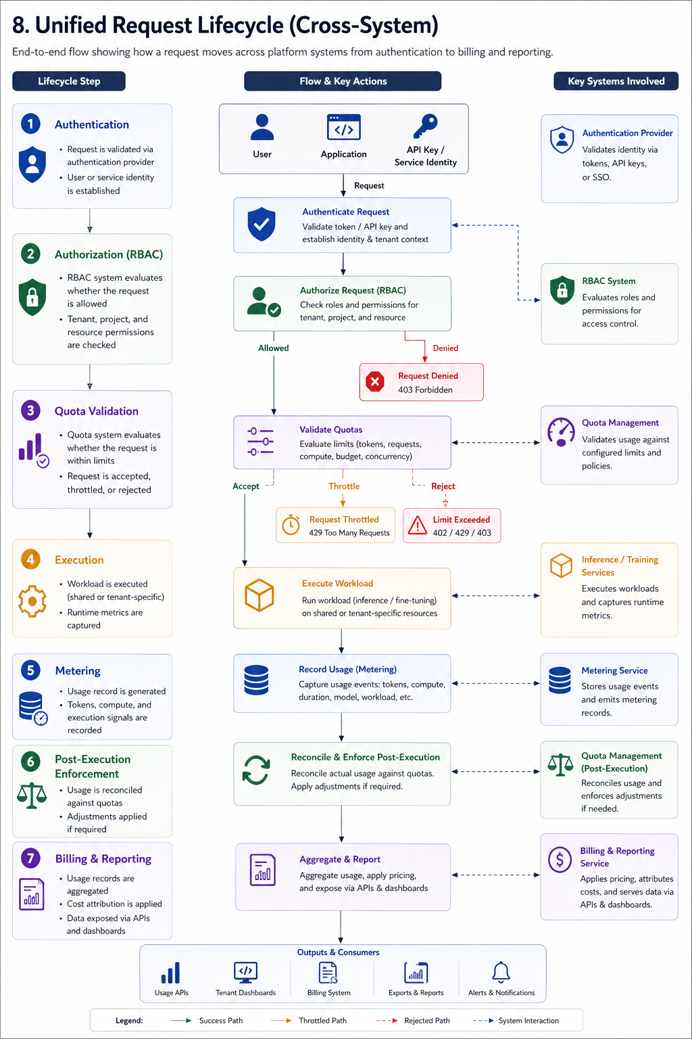

9. Core Capabilities

9.1 Tenant Isolation
The system ensures:
- separation of:
  - data
  - inferencing endpoints
  - usage records
- independent configuration per tenant:
  - limits
  - access controls
- no cross-tenant leakage in:
  - responses
  - logs
  - caches
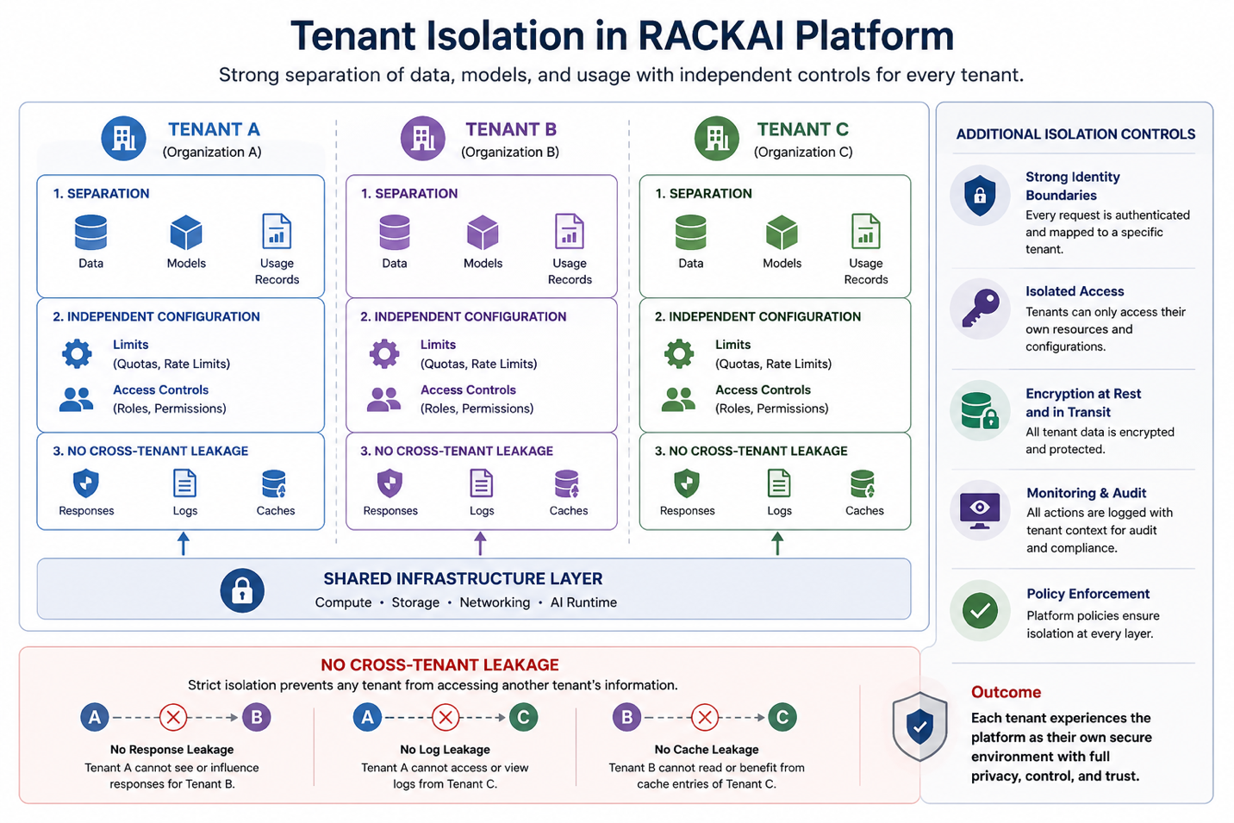

9.2 Workload Execution Model
The platform supports both:
- Tenant-specific execution
Workloads such as fine-tuning or inferencing run in isolation for a single tenant.
- Shared execution
Common workloads, such as base model inference, are executed on shared infrastructure across multiple tenants.
In both cases, the platform ensures:
- strict data isolation
- fair usage
- accurate usage attribution
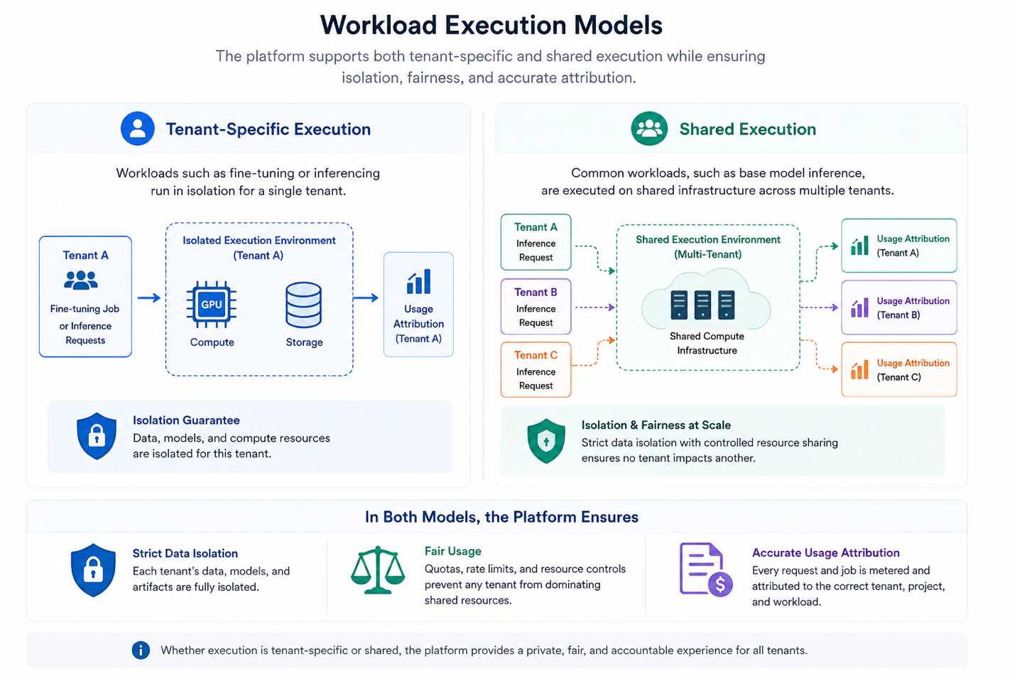

9.3 Unified Metering Across the Lifecycle
All usage is tracked consistently across:
- model deployment
- fine-tuning
- inference
Metering must:
- Attribute all usage to a tenant and project
- Capture both logical usage and underlying resource consumption
- Be consistent across all workload types
- Be reliable, auditable, and tamper-resistant

9.4 Metered Usage Dimensions
The platform captures multiple dimensions of usage to ensure accurate measurement and attribution across all workloads.

Inference Usage
- Input tokens (tokens sent to the model)
- Output tokens (tokens generated by the model)
- Total tokens processed

Caching & Reuse
- Cached tokens (reused via prefix/KV cache or similar mechanisms)
- Differentiation between:
  - newly processed tokens
  - reused/cached tokens
Caching must be tenant-aware to prevent cross-tenant leakage and ensure accurate usage attribution.
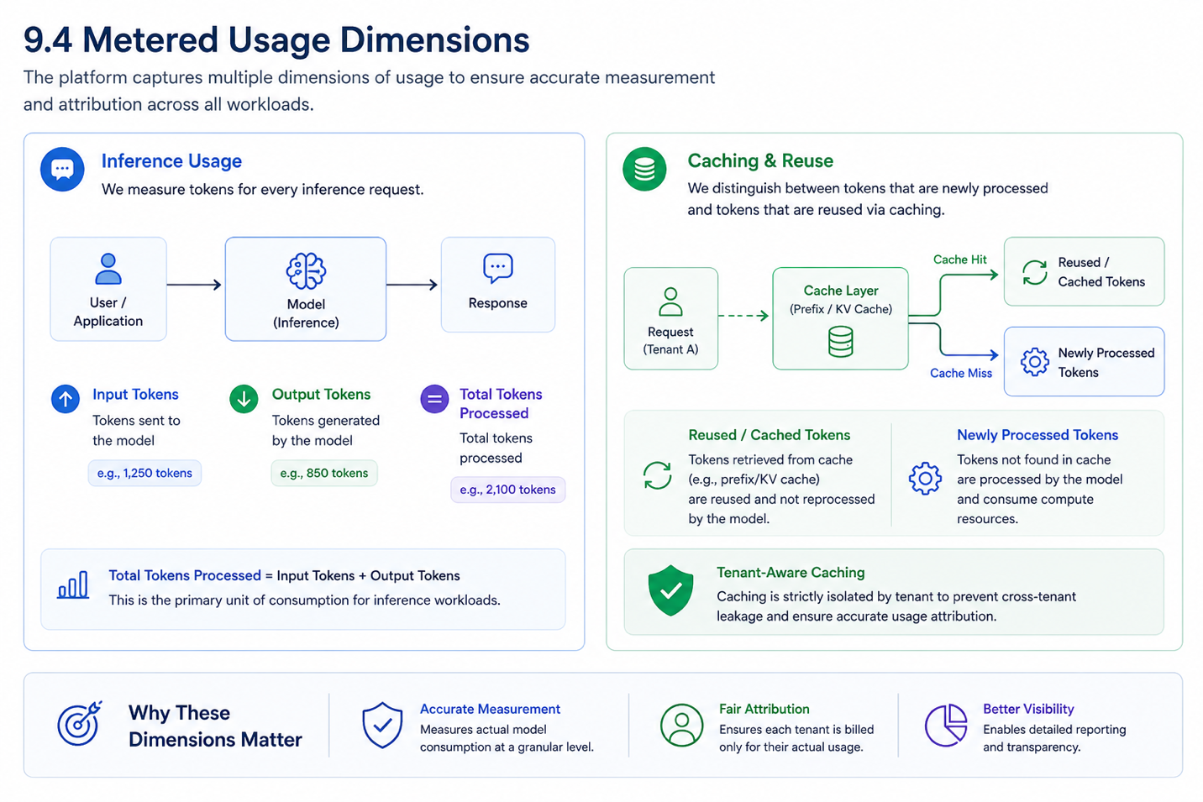

9.5 Compute & Execution Signals
To reflect actual resource consumption, the platform should track:
- Compute time
Time spent executing the workload on compute resources (e.g., GPU)
- Tokens processed
Primary unit of consumption for inference workloads
- Execution type
Whether the workload runs as shared execution or tenant-specific execution

Fine-Tuning Usage
- duration of tuning jobs
- compute resources consumed (eg GPU VRAM)

Fine-Tuning Data Usage
- dataset size (GB)
- data processed during training
- storage duration

9.6 Key Requirements
- Metering must be:
  - accurate at the request level
  - aggregatable over time (per tenant, project, model)
  - consistent regardless of execution model (shared or isolated)
- All usage must be:
  - traceable to a specific workload
  - aligned with billing and reporting systems
- All metering must be performed at the request or job level and aggregated across tenants, projects, and models.
- Usage records must be retained for a defined period to support billing and audit requirements
- Historical data must be queryable at tenant, project, and workload level
- Audit trails must support reconciliation of usage and cost

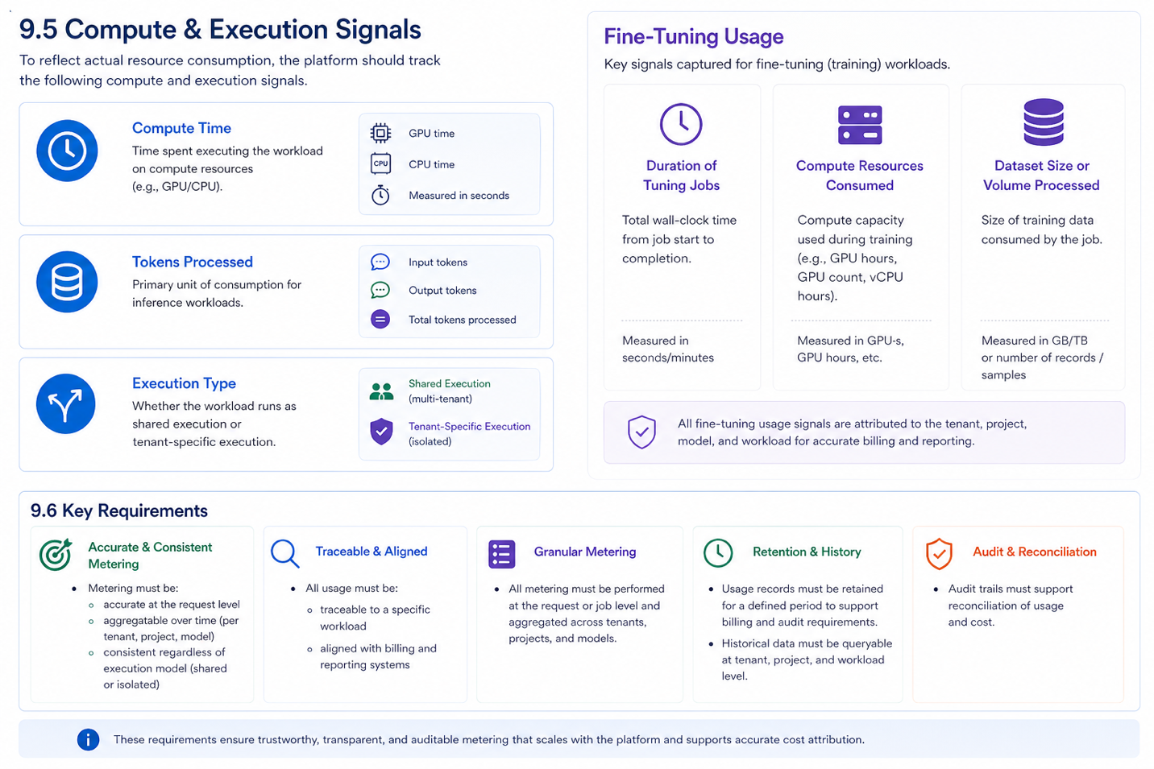

9.7 Metering Event Structure (Conceptual)
Each workload (inference request or training job) must generate a usage record with the following attributes:
- tenant_id
- project_id
- workload_id
- model_id
- workload_type (inference / fine-tuning)
- adapter_id (LoRA)
Workload Identity Requirements
- workload_id must be globally unique within the system
- workload_id must be consistent across retries and reprocessing
- workload_id must allow traceability across metering, enforcement, and billing systems
Usage Metrics
- input_tokens
- output_tokens
- cached_tokens
Execution Metrics
- compute_time
- queue_time
- latency
Execution Context
- execution_type (shared / tenant-specific)
- timestamp

All usage records must be uniquely identifiable and support aggregation across tenants, projects, and models.

9.8 Consistency Model
- Metering and usage reporting may operate under eventual consistency
- Quota enforcement must operate in real time
This ensures:
- accurate billing and reporting over time
- immediate enforcement of limits to protect system stability

9.9 Idempotency & Reliability
Metering systems must ensure:
- usage records are idempotent, preventing double counting in the event of retries or failures
- failures in metering pipelines do not block workload execution
- usage data is retried or reconciled in case of temporary failures

10. Cost Attribution & Transparency
Cost is derived directly from the metered usage dimensions defined in Section 8.3.

Cost Attribution
The platform provides a clear and consistent mapping from usage to cost, enabling:
- attribution of cost to tenant, project, and workload
- alignment between consumption and billing

Primary Cost Drivers
Cost is determined by the following factors:
- token usage (input vs output)
- compute usage (training and inference)
- workload type:
  - shared execution
  - tenant-specific execution
- efficiency factors such as caching and reuse

Shared Inference Cost Attribution
The platform supports shared inference execution, where requests from multiple tenants may be processed on the same underlying model instance or execution batch to improve efficiency.

Shared Execution Model
In shared inference:
- multiple tenant requests may be:
  - executed on the same model instance
  - batched together for processing
- underlying compute resources are shared across tenants
- execution efficiency is improved through batching and reuse

Attribution Principle
Even when execution is shared, usage must be attributed at the individual workload level.
Each tenant is billed based on:
- their own input tokens
- their own output tokens
- their own usage of compute and system resources
Shared infrastructure must not result in:
- cross-tenant cost leakage
- incorrect attribution
- loss of billing transparency

Cost Allocation Model
Cost attribution for shared inference is based on:
- token-based usage
  - input tokens
  - output tokens

Caching Considerations
When caching (e.g., prefix/KV cache) is used:
- only the tenant benefiting from cached tokens receives the cost reduction
- caching must remain tenant-aware to prevent cross-tenant benefit leakage
- cached tokens may be billed differently from newly processed tokens

Transparency Requirements
Tenants must be able to:
- understand how their usage was measured
- see the breakdown of token usage (input, output, cached)
- verify that they are only billed for their own workloads

Outcome
This ensures:
- efficient use of shared infrastructure
- fair and accurate cost attribution across tenants
- preservation of trust in usage-based billing

Visibility
Users can access:
- usage by model
- usage over time
- usage by project or workload
- key cost drivers contributing to spend

Transparency Requirements
Users must be able to:
- understand how their usage translates into cost
- identify which workloads are driving spend
- track cost trends over time
- reconcile usage with billing

User-Level Clarity
At any point, users should be able to answer:
“What did we run, and why did it cost this much?”

Example: Usage & Cost Breakdown
Below is an example of how a tenant’s usage may be presented to provide clarity on cost drivers.

Tenant: Acme Corp
Project: Customer Support Bot
Time Period: March 2026

Inference Usage (Shared Model)
Metric | Value
Input Tokens | 12,000,000
Output Tokens | 4,000,000
Cached Tokens | 6,000,000
Total Requests | 85,000

Cost Drivers:
- Majority of cost driven by new token processing
- Cached tokens reduce overall compute cost

Fine-Tuning Usage (Tenant-Specific Execution)
Metric | Value
Training Jobs | 3
Total Training Time | 18 hours
Dataset Size | 25 GB
Total Resource USAge | 2*H100(168GB)
Cost Drivers:
- Compute time for training jobs
- Dedicated resource usage during fine-tuning

Execution Breakdown
Workload Type | % of Usage | Notes
Shared Inference | 80% | Efficient, lower cost per request
Tenant-Specific Jobs | 20% | Higher cost due to isolation

Total Estimated Cost
Category | Cost
Inference | $2,400
Fine-Tuning | $1,200
Total | $3,600

Key Insights
- Token usage (especially input tokens) is the primary cost driver
- Caching reduced compute requirements and improved efficiency
- Fine-tuning jobs contributed disproportionately due to dedicated resources

User-Level Explanation
“Most of your cost came from high input token usage in your support bot.
Costs were reduced by caching repeated prompts, while fine-tuning jobs added fixed compute costs due to dedicated execution.”

API-Accessible Metering & Billing
Metering and billing data must be accessible through platform APIs so tenants and internal systems can programmatically retrieve usage and cost information.
The APIs should support access to:
- usage by tenant, project, model, and workload
- inference usage, including input tokens, output tokens, cached tokens, and total requests
- fine-tuning usage, including job duration, compute usage, and dataset volume where applicable
- quota consumption and remaining limits
- cost estimates and billing-period summaries
- historical usage over configurable time ranges
API access must respect tenant isolation and access policies, ensuring users can only retrieve usage and billing data they are authorized to view.
This enables:
- customer-facing dashboards
- internal reporting
- billing reconciliation
- automation and cost governance
- integration with finance or FinOps tooling

11. Fair Usage & Quota Enforcement
The platform enforces controls to ensure fair access to shared resources and predictable performance across tenants.

Enforcement Mechanisms
The system enforces defined limits through:
- Rate limiting
Controls the rate of incoming requests or token processing over time
- Throttling and queueing
Delays or regulates requests when limits are approached or exceeded
- Concurrency control
Limits the number of simultaneous requests or jobs executed per tenant
- Prioritization
Allocates resources based on tenant tier, workload type, or system conditions

Enforcement Timing
Quota enforcement must occur at multiple stages:
- Pre-execution (admission control)
  - Validate quotas before accepting requests or jobs
- During execution
  - Apply rate limits and concurrency controls
- Post-execution (reconciliation)
  - Adjust usage records and correct discrepancies

Scope of Enforcement
Enforcement applies consistently across:
- inference workloads (token-based usage)
- fine-tuning and training workloads (compute-based usage)
- both shared and tenant-specific execution models

Enforcement Principles
- Fairness
No tenant can monopolize shared resources or degrade others’ performance
- Predictability
System behavior is consistent and aligned with defined limits
- Graceful Degradation
When limits are reached:
  - requests are throttled or queued
  - workloads are delayed or rejected as needed
  - clear feedback is returned to the user
- Transparency
All enforcement actions are visible and explainable
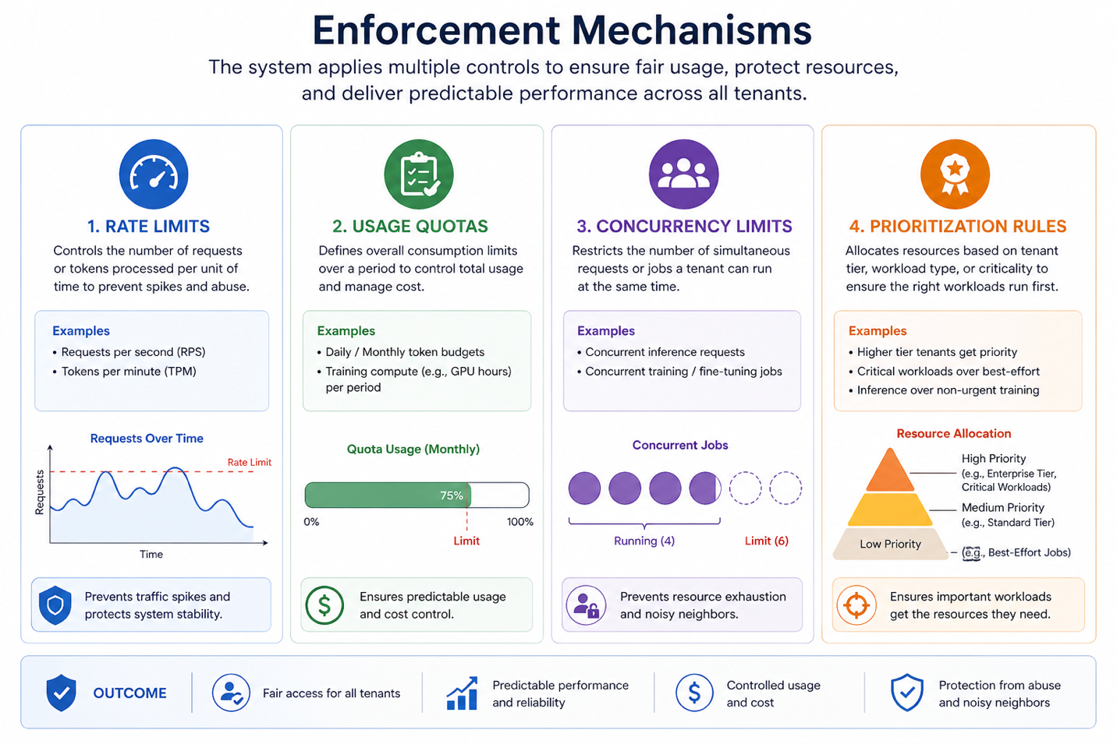

Budget Protection
The platform must prevent unexpected or uncontrolled spending through:
- Soft budget limits
  - trigger alerts and warnings
  - allow continued usage with visibility
- Hard budget limits
  - enforce strict caps on usage
  - prevent additional requests or jobs from executing

Enforcement Behavior
When budget limits are reached:
- inference requests may be throttled or rejected
- new training or fine-tuning jobs may be blocked
- clear feedback is provided to the user

Outcome
This ensures:
- consistent performance across tenants
- protection from noisy neighbor scenarios
- controlled and sustainable platform usage

12. Usage Visibility
The platform provides clear, real-time, and historical visibility into usage and consumption, enabling tenants to understand and control their costs.

Real-Time Visibility
Users can monitor:
- current usage against quotas (e.g., tokens consumed vs limits)
- active requests and running jobs
- near-real-time indicators of spikes or anomalies

Historical Insights
Users can access:
- usage trends over time
- cost evolution
- workload patterns across different time periods
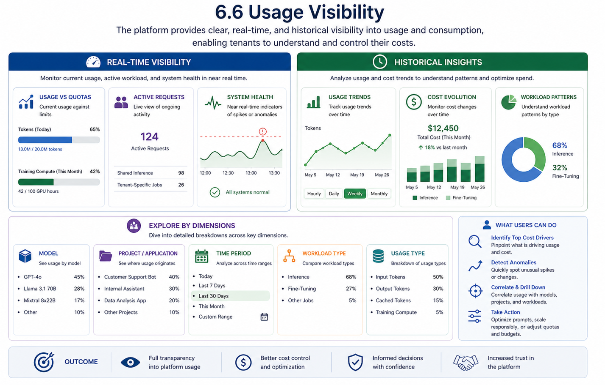

Breakdowns & Dimensions
Usage must be explorable across key dimensions:
- Model (which models are driving usage)
- Project / application (where usage originates)
- Time period (hourly, daily, monthly trends)
- Workload type:
  - inference
  - fine-tuning
- Usage type:
  - input tokens
  - output tokens
  - cached tokens
  - training compute

User Capabilities
Users should be able to:
- identify top cost drivers
- detect unusual usage patterns
- correlate usage with specific workloads or deployments
- make informed decisions about:
  - scaling usage
  - optimizing prompts or models
  - adjusting quotas or budgets
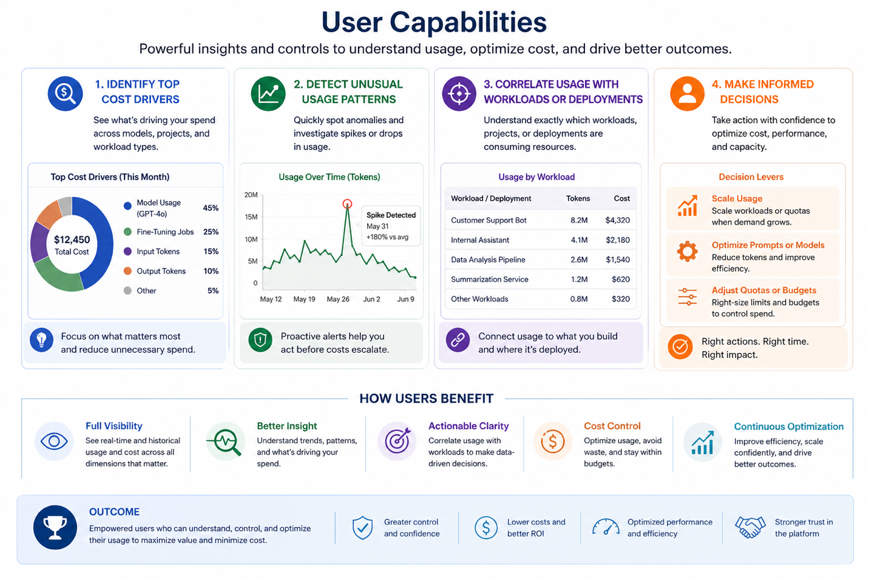

Outcome
This ensures:
- full transparency into platform usage
- better cost control and optimization
- increased trust in the platform

Example: Behavior When Limits Are Reached
The platform must handle quota and limit breaches in a predictable, transparent, and user-friendly way.

Scenario: Tenant Approaches Token Limit
- Early Warning (Pre-Limit)
  - The system notifies the tenant when usage approaches a defined threshold (e.g., 80–90%)
  - Indicators appear in:
    - dashboards
    - API responses (optional metadata)
- Limit Reached (Soft Enforcement)
When a limit is reached, the system responds based on workload type:
- Inference (shared workloads):
  - Requests are throttled or rate-limited
  - Some requests may be queued or delayed
- Training / fine-tuning jobs:
  - New jobs are rejected or queued
  - Running jobs are allowed to complete (where possible)
- Clear error or status messages are returned:
“Quota exceeded: token limit reached for this billing period”
- Post-Limit Recovery Options
Tenants can:
- Increase quota / upgrade limits
- Wait for quota reset (e.g., next billing cycle)
- Optimize usage:
  - reduce token consumption
  - leverage caching
  - pause workloads

System Behavior Principles
- No silent failures
Every rejected or throttled request returns a clear reason
- Graceful degradation
The system slows or limits usage instead of abruptly failing
- Consistency
The same rules apply across all workloads and tenants
- Visibility
Users can see exactly:
  - what limit was hit
  - why it happened
  - what to do next

Outcome
Tenants experience limits as:
- predictable
- understandable
- manageable
rather than disruptive or confusing.

13. Quota Types
The platform supports multiple types of quotas to define and control usage across different workload types.

1. Token-Based Quotas (Inference)
Controls usage based on the number of tokens processed:
- input tokens
- output tokens
- total tokens processed
Optional:
- cached tokens tracked separately to reflect reuse and efficiency
Examples:
- tokens per minute (rate limit)
- tokens per day or month (budget quota)

2. Request-Based Quotas
Controls the number of API requests:
- requests per second (RPS)
- requests per minute

3. Concurrency Quotas
Limits the number of simultaneous operations:
- concurrent inference requests
- concurrent training or fine-tuning jobs

4. Compute-Based Quotas (Training / Fine-Tuning)
Controls resource usage for training workloads:
- total training time (e.g., GPU hours)
- number of training jobs
- resource class limits (if applicable)

5. Budget-Based Quotas
Defines limits based on monetary usage:
- monthly spend limits
- per-project budget caps

Quota Behavior Requirements
All quotas must:
- be visible in real time
- be configurable per tenant or project
- be consistently enforced by the system
- align with metering and billing systems

How Quotas Work Together
Quotas operate in combination to ensure balanced control:
- token quotas manage inference usage
- request and concurrency quotas manage system load
- compute quotas manage training cost and capacity
- budget quotas provide financial control
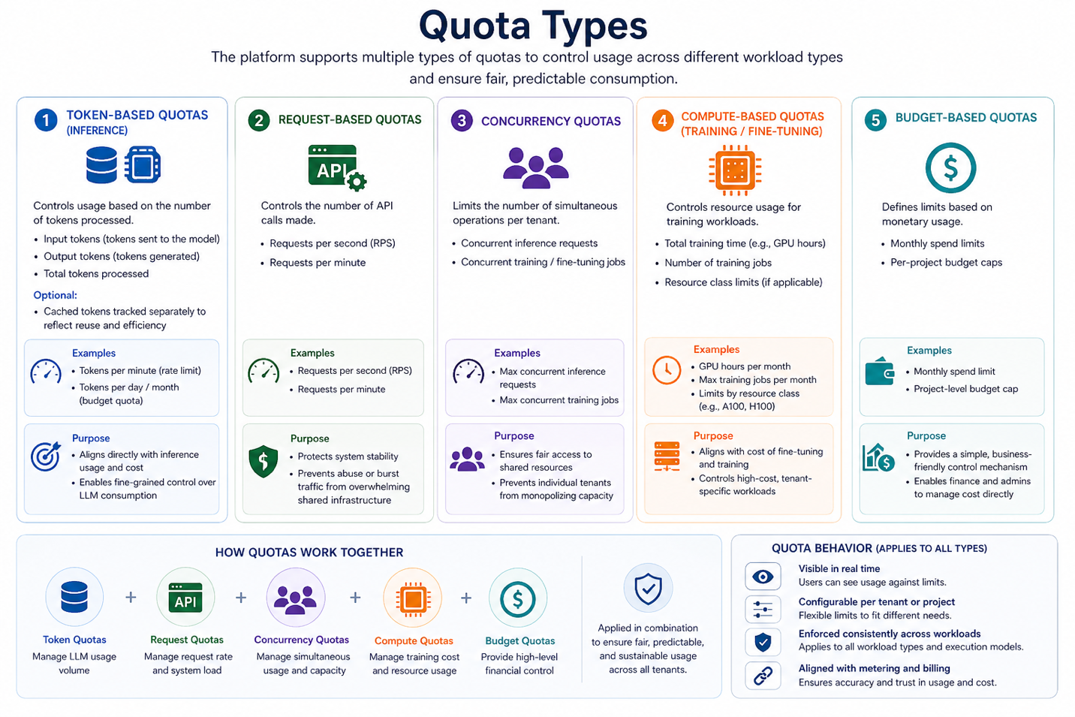

Outcome
This multi-layered quota system ensures:
- fair and predictable access to shared infrastructure
- strong alignment between usage and cost
- flexibility for different tenant needs

14. Key Risks
The platform must account for the following risks:

1. Inaccurate Metering
Incorrect or inconsistent usage tracking may lead to:
- billing discrepancies
- loss of customer trust
- financial impact

2. Cache Misuse or Misattribution
Improper handling of cached tokens may result in:
- incorrect cost attribution
- potential cross-tenant data concerns

3. Noisy Neighbor Effects
Insufficient enforcement of limits may cause:
- performance degradation for other tenants
- inconsistent user experience

4. Quota Misconfiguration
Incorrect quota settings may lead to:
- unexpected service interruptions
- over-restriction or over-consumption

5. Lack of Cost Transparency
If users cannot clearly understand their usage:
- trust in the platform may decrease
- cost disputes may increase

6. Mitigation Approach
These risks are addressed through:
- strong metering accuracy and validation
- tenant-aware isolation and caching
- robust quota enforcement mechanisms
- clear usage visibility and reporting

15. Failure Handling
The system must handle failures gracefully without compromising accuracy or stability:
- If metering fails:
  - workloads must still complete
  - usage must be retried or reconciled
- If quota enforcement fails:
  - system should default to safe limits
  - prevent uncontrolled resource usage
- If visibility is delayed:
  - usage must still be recorded accurately
  - reporting systems may catch up asynchronously
- Reconciliation & Backfill
  - The system must support recomputation or correction of usage records in case of errors
  - Adjustments must be traceable and auditable
  - Corrections must propagate to billing and reporting systems

16. Success Criteria
- 100% of usage attributable to tenant, project, and workload
- zero cross-tenant data leakage
- Quota enforcement must not add significant latency to request processing
- <1% billing discrepancy
- consistent latency across tenants within defined thresholds
- quota enforcement accuracy = 100%
- metering and billing data is available through APIs with tenant-scoped access controls.

17. Summary
This foundation enables the platform to scale by ensuring that shared AI infrastructure behaves as if it were private, predictable, and fully accountable for every tenant.
By combining strong multi-tenancy with unified metering and enforcement, the platform provides a consistent and reliable way to:
- measure usage accurately across all workloads
- control resource consumption in real time
- attribute cost transparently to tenants, projects, and workloads

Platform Impact
This foundation establishes:
- A trust layer for customers
Tenants can rely on strict isolation, predictable performance, and clear visibility into their usage and cost, enabling them to adopt and scale AI workloads with confidence.
- A control layer for the platform
The system enforces fairness, prevents resource contention, and provides mechanisms to manage usage, quotas, and budgets across all tenants.
- A revenue foundation for the business
Accurate metering and cost attribution enable scalable, usage-based pricing models that align infrastructure consumption with revenue.

Operational Outcome
With this foundation in place, the platform can:
- support efficient sharing of infrastructure without compromising isolation
- scale across tenants and workloads while maintaining performance and fairness
- provide auditable, reliable data for billing, reporting, and compliance
- enable automation, optimization, and cost governance through APIs and visibility

Final Statement
This is not just an infrastructure capability, it defines how the platform measures, controls, and monetizes AI usage.
It is the core system that allows RACKAI to operate as a scalable, trusted, and enterprise-ready AI platform.

